General
This document will take you through a simple form building that uses a Form Window component. The Demonstration Toolkit and Demonstration Application currently provide three examples of Form Window components (imager, demographic form, and narration window). In this example, we will make use of the imager sample.
Note that the implementation of Form Windows is a functionality that simply exposes a container on the form page to your application. It is up to the application to implement the window content. Use the source code of the demo (VB or DotNet) to determine how to appropriately connect your application to Form Windows.

Steps
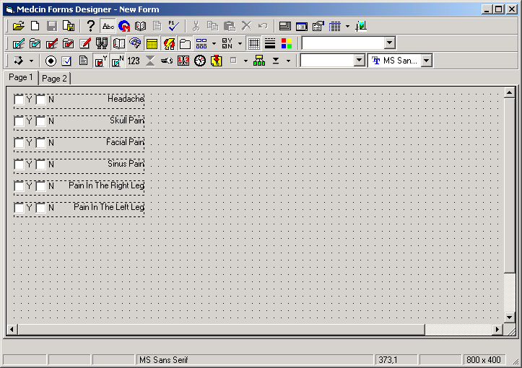
Start a new form and add the findings as shown in this image:

Select the Window tool and draw a rectangle that will be used to locate your window. The following dialog will be presented by the Demonstration Toolkit application. For our example, we want to use an imager so select the ‘Image Annotation Module’ entry from the list box, then press the OK button.
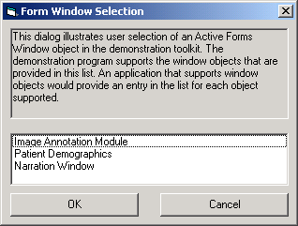

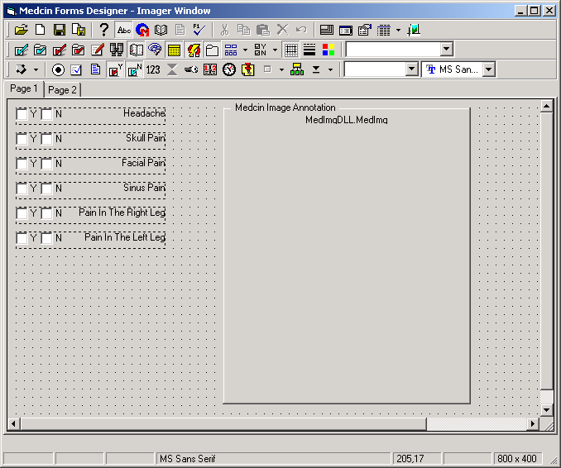
The form will now appear as follows:
Form Windows can be ‘border styled’ or not. The choice can be determined by the application at run time for its own purposes. In the demo, a border styled imager window will be always visible whereas one without a border will be visible only when it is shown. The demo also enables the Active Form’s “Add object to finding” and “Show attached object” context menu items for a finding’s context menu. It is via these menu items that the imager surfaces and can be used.
Save the form using a name of ‘Imager Window”.
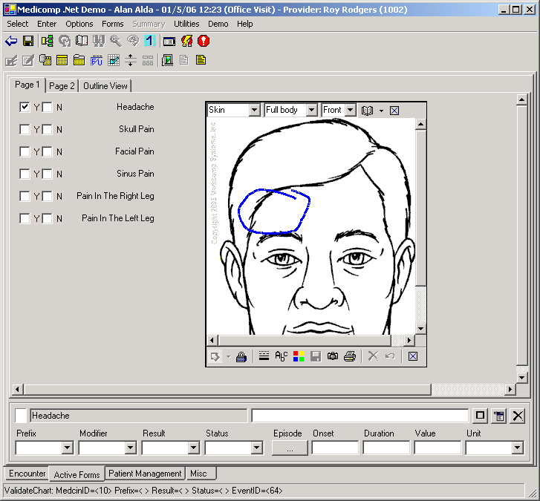
When that form is used in the DotNet TestGUI or VB MedcinDemo (Select patient, start encounter, Select Active Forms, and choose the form Imager Window form), selecting any of the findings does not show the imager window. The imager window is shown when you enter a finding (check the Y button for headache), then get the context menu by pressing the entry details menu button. Choose the “Add object to finding” menu item to show the imager.
This approach uses the ModImage module that incorporates an image selector. The demo application has code to choose a default image based on the specialty code property of the finding. But the selector can be used to choose any Medicomp-provided image. A user image can be chosen using the picture toolbar button (this requires support from the application).
If you select the Skin, Head-Neck, front image, then draw an annotation, saving the annotation will close the imager. Use the ‘Show attached object’ context menu item to present the imager with the annotated image.

